1. Name the tense: We use it to describe an action in progress in the past, or an incompleted one interrupted by another action

Past continuous

2. Name the tense: We use it to describe a spontaneous decision, a prediction based on your opinions and to talk about schedules

Future simple

3. Complete: Andy's losing control of the surfboard. He ____________ (fall off)!

Andy's losing control of the surfboard. He's going to fall off!

4. Complete: + Why are you so angry? - Because I __________ (wait) for you for hours

Because I have been waiting for you for hours

5. Complete: + Do you like curry? - I don't know, I _________ (never/try) it.

I don't know, I have never tried it.

6. Rephrase: Is this your first time here? (before)

Have you (ever) been here before?

7. Complete: I _________ (cook) dinner when I cut my hand.

I was cooking dinner when I cut my hand.

8. Complete: How many languages _______ you ________ (speak)?

How many languages do you speak?

9. Name the tense: We use it to describe an action in progress at a certain future time

Future Continuous

10. Rephrase: Our guests arrived a few minutes ago. (just)

Our guests have just arrived.

11. Rephrase: She was too impatient to wait for us to arrive, so she left. (by the time)

By the time we arrived, she had already left

12. Rephrase: The last time I saw her was was a year ago. (for)

I haven't seen her for a year.

13. Complete: By the end of next week, I __________ (finish) all my exams.

By the end of next week, I will have finished all my exams.

14. Complete: Listen to them! What _______ they _______ (speak)? Is it Portuguese?

Listen to them! What are they speaking? Is it Portuguese?

15. Rephrase: When did you begin to write the travel blog? (how long)

How long have you been writing the travel blog?

16. Complete: Finally, summer's here! This time next week I ___________ (sit) here any more!.

Finally, summer's here! This time next week I won't be sitting here any more!

17. Name the tense: We use it to talk about an action that took place at an indefinite time in the past

Present Perfect

18. Complete: He was furious because I _________ (make) a lot of mistakes.

He was furious because I had made a lot of mistakes.

19. Name the tense: We use it to describe an action that started in the past and continues in the present

Present Perfect Continuous

20. Rephrase: I missed my flight. That's why I was late. (because)

I was late because I had missed my flight.

21. Name the tense: We use it to describe an action that is about to happen and a future plan

Be going to

22. Name the tense: We use it to describe an action completed at a certain future date

Future perfect

23. Name the tense: We use it to describe something happening now or a future plan

Present Continuous

24. Complete: Jenny _______ (cut) her hand while making dinner

Jenny cut her hand while making dinner

25. Name the tense: We use it to describe an action that happened before another action in the past

Past Perfect

26. Name the tense: We use it to describe a finished action in the past

Past simple

27. Name the tense: We use it to describe a regular habit/routine and general facts

Present Simple

28. Complete: Go to sleep. You ________ (feel) better tomorrow

Go to sleep. You'll feel better tomorrow

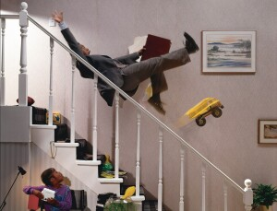

1. He was walking down the stairs when he stepped on a toy truck and fell.

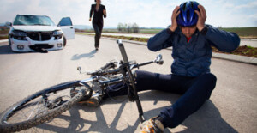

2. He was riding his bike when he was hit by a car.

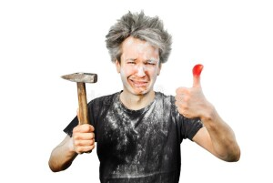

3. He was hammering nails when he hit his thumb.

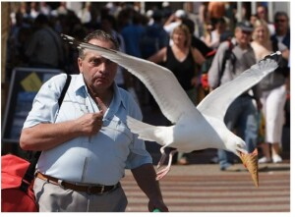

He was eating ice cream when a sea gull suddenly stole it out of his hand.

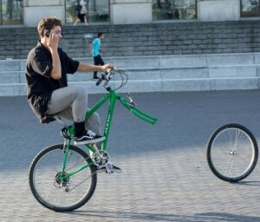

He was riding his bicycle when the front wheel fell off.

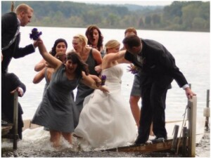

They were posing for wedding photos when the dock collapsed.

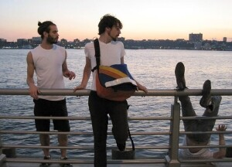

He was sitting on a railing when he fell into the river.

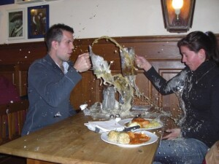

They were toasting each other when their glasses shattered.

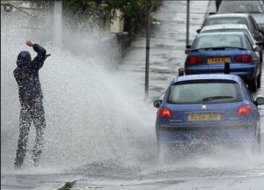

He was walking along the road when a car drove through a puddle and splashed him.

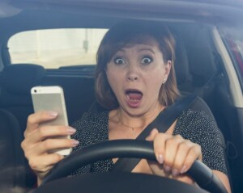

She was using her phone while driving when she had an accident.

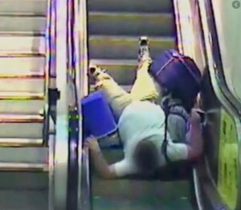

He was riding up the escalator when he fell.



He was eating dinner when he dropped spaghetti on his shirt.

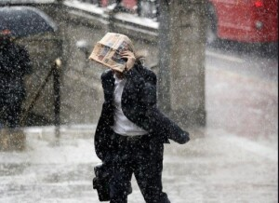

He was walking to work when it started raining.

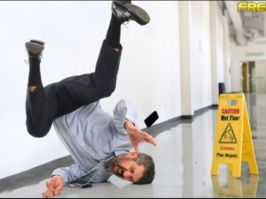

He was walking down the hall when he slipped on the wet floor.

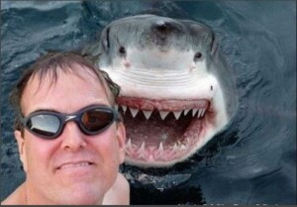

He was taking a selfie when a great white shark photobombed him.

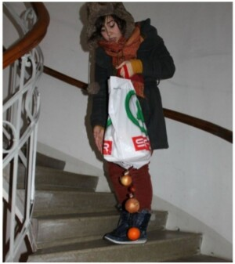

She was carrying her groceries up the stairs when her bag broke.

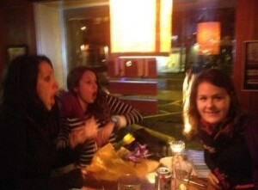

She was blowing out her birthday cake candles when her hair caught on fire.

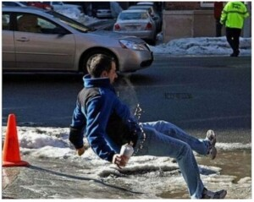

He was walking when he slipped on ice.

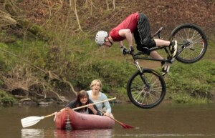

They were canoeing down the river when a bicyclist fell from the sky.

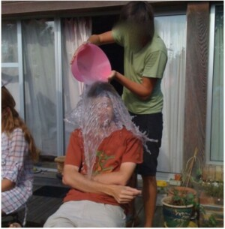

He was relaxing when his friend dumped a bucket of water on his head.

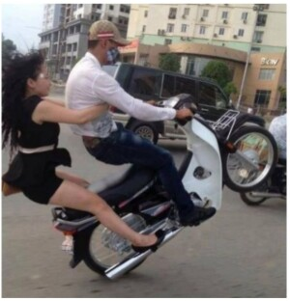

Riding a motorcycle, an unexpected occurrence resulted in the passenger falling off.



He was driving his car when a police officer stopped him.



Carrying a birthday cake, she accidentally dropped it.

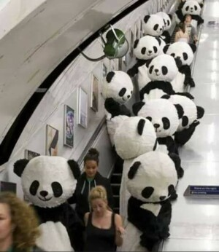

En route to the subway, they were surprised when a panda convention unexpectedly arrived.

1. Michael: What....you.... (wear) in the party last week? Sarah: I.....(wear) a red dress.

Michael: What did you wear in the party last week? Sarah: I wore a red dress.

2. I..... (fly) to Madrid next week. I..... (buy) the ticket and..... (set) the hotel room a few days ago.

I am flying to Madrid next week. I bought the ticket and set the hotel room a few days ago.

3. She..... (not/usually/play) voleyball. Because she..... (hate) doing sport.

She doesn't usually play voleyball. Because she hates doing sport.

4. Son: Mom, are you okay? You..... (look)very tired. Mother: Yes, I..... (clean) the house all day.

Son: Mom, are you okay? You look very tired. Mother: Yes, I have been cleaning the house all day.

5. She..... (hate) you. You...... (always/shout) at her.

She hates you. You are always shouting at her.

6. The workers..... (paint) my uncle's house now. . He....(stay) with us until his house is ready.

The workers are painting my uncle's house now. He is staying with us until his house is ready.

7. Sam: ..... (be) you at school yesterday? Mary: No, I..... (go) to school.

Sam: Were you at school yesterday? Mary: I didn't go to school.

8. She..... (drink) five cups of coffee since the morning.

She has drunk five cups of coffee since the morning.

9. ..... (not/make) noise! The baby..... (sleep).

Don't make noise. The baby is sleeping.

10. Adam: Can you help me to study for my exam? Daniel: Okay, I..... (help) you

Adam: Can you help me to study for my exam? Daniel: Okay, I will help you.

11. I think our teachers..... (not/give) us homework next week.

I think our teachers won't give us homework next week.

12. Why..... your brother.....(read) a book once every two weeks?

Why does your brother read a book once every two weeks?

13. How long..... he..... (stay) in Paris last summer? He..... (stay) in Paris for two weeks.

How long did he stay in Paris? He stayed in Paris for two weeks.

14. Why..... your parents..... (speak) with my parents at this time yesterday?

Why were your parents speaking with my parents at this time yesterday?

15. There are many clouds in the sky. It..... (rain)

There are many clouds in the sky. It is going to rain.

16. How..... your mother..... (go) to work? She..... (go) to work by bus.

How does your mother go to work? She goes to work by bus.

17. Can't you see? The road is wet. Don't run. You..... (fall)

Can't you see? The road is wet. Don't run. You are going to fall.

18. As my friend..... (watch) TV yesterday, I.... (do) my homework.

As my friend was watching TV yesterday, I was doing my homework.

19. They..... (already/do) their homework, so they..... (ride) a bike at the moment.

They have already done their homework, so they are riding a bike at the moment.

1. Q: Where are my jeans? A: They _____ (wash) at the moment.

Q: Where are my jeans? A: They are being washed at the moment.

2. I ______ (not be) this full for so long.

I haven't been this full for so long.

3. I felt tired because I _____ (attend) a party the night before.

I felt tired because I had attended a party the night before.

4. Samantha _____ (live) in Berlin for over twenty years. In fact, she _____ (live) there when the Berlin Wall came down.

Samantha has been living in Berlin for over twenty years. In fact, she was living there when the Berlin Wall came down.

5. Over the last one hundred years, travelling _____ (become) very comfortable and much easier. In the 19th century it _____ (take) two or three months to cross America.

Over the last one hundred years, travelling has become very comfortable and much easier. In the 19th century it took two or three months to cross America

6. I _____ (see) many pictures of pyramids before I went to Egypt. But when I _____ (see) them in real life, they _____ (look) quite small.

I had seen many pictures of pyramids before I went to Egypt. But when I saw them in real life, they looked quite small.

7. The students are usually _____ (teach) by Mr. Bingham. However, this week, they _____ (teach) by the assistant teacher.

The students are usually taught by Mr. Bingham. However, this week, they are being taught by the assistant teacher.

8. When the medical team found her, she _____ (bleed) out of her nose.

When the medical team found her she was bleeding out of her nose.

9. How _____ you usually _____ (get) to work?

How do you usually get to work?

10. When I _____(open)the cupboard, all the cups and pans _____ (fall) out.

When I opened the cupboard, all the cups and pans fell out.

11. I _____ (work) for this company for more than thirty years and I _____ (intend) to stay here until I retire.

I have been working for this company for more than thirty years and I intend to stay here until I retire.

12. When we finally got to the village we _____ (travel) for over five hours. We were exhausted.

When we finally got to the village we had been travelling for over five hours. We were exhausted.

13. The Mets _____ (not win) a game so far this season.

The Mets has not won a game so far this season.

14. Every day I _____ (wake) up at six, _____ (eat) breakfast at seven and _____ (leave) for work at eight. However, this morning I _____ (get) up at 6:30, _____ (skip) breakfast and _____ (leave) for work late.

Every day I wake up at six, eat breakfast at seven and leave for work at eight. However, this morning I got up at 6:30, skipped breakfast and left for work late

15. Thomas is an author who _____ (write) since he was a child. Altogether he _____ (write) seven novels and three collections of short stories.

Thomas is an author who has been writing since he was a child. Altogether he has written seven novels and three collections of short stories.

16. How long _____ you _____ (have) your own office?

How long have you had your own office?

17. We ______ (take) this picture last Christmas.

We took this picture last Christmas.

18. I _____ (not travel) too much yet but by the time I leave the United States I _____ (visit) the Grand Canyon and San Francisco.

I have not travelled too much yet but by the time I leave the United States I will have visited the Grand Canyon and San Francisco.

19. The phones _____ (ring) since the news was announced in the morning.

The phones have been ringing since the news was announced in the morning.

20. I _____ (have) the same car for more than ten years. I am thinking about buying a new one.

I have had the same car for more than ten years. I am thinking about buying a new one

21. You _____ (not eat) very much. Aren't you hungry?

You haven't eaten very much. Aren't you hungry?

22. Right now Jim _____ (prepare) dinner and Sandra _____ (bring) the children to bed. Last night at this time they _____ (do) the same thing.

Right now Jim is preparing dinner and Sandra is bringing the children to bed. Last night at this time they were doing the same thing.

23. You look really great! _____you _____ (exercise) at the fitness center lately?

You look really great! Have you been exercising at the fitness center lately?

24. I _____ (tell) you the whole story later.

I will tell you the whole story later.

25. When we got to Central Park, people _____ (walk) and children _____ (play).

When we got to Central Park, people were walking and children were playing.

26. Look over there. Someone _____ (try) to get on the moving bus.

Look over there. Someone is trying to get on the moving bus.

27. Q: What do you call people who work in libraries? A: I think they _____ (call) librarians.

What do you call people who work in libraries? I think they are called librarians.

28. Sometimes I _____ (drive) myself to work, and in bad weather I usually _____ (take) the bus.

Sometimes I drive myself to work, and in bad weather I usually take the bus.

29. Q: Where are they? A: They _____ (come) now.

They are coming now.

30. She _____ (be) to the hospital three times before she was allowed to play again.

She had been to the hospital three times before she was allowed to play again.

31. Rachel ____ (jog) for an hour every morning.

Rachel jogs for an hour every morning.

32. Please be quiet! John _____ (sleep).

Please be quiet! John is sleeping.

33. Prices _____ (go) up. Everything is so expensive this year.

Prices have gone up. Everything is so expensive this year.

34. While we _____ (wait) for the bus we _____ (see) two children flashing by with their roller skates.

While we were waiting for the bus we saw two children flashing by with their roller skates.

35. My elder brother _____ (be) in a coma for over a week.

My elder brother has been in a coma for over a week.

36. Dad always _____ (make) breakfast for us.

Dad always makes breakfast for us.

37. Helen _____ (find) life in Madrid difficult at the moment.

Helen is finding life in Madrid difficult at the moment.

38. _____ you _____ (see) the new Marvel movie yet?

Have you seen the new Marvel movie yet?

39. I _____ (not see) my friends since July.

I haven't seen my friends since July.

40. We were late because we _____ (have) some car problems. By the time we got to the train Susan _____ (wait) for us for more than two hours.

We were late because we had some car problems. By the time we got to the train Susan had been waiting for us for more than two hours.

41. My husband _____ never _____ (get) me flowers before.

My husband has never gotten me flowers before.

42. Joe's English _____ really _____ (improve), isn't it?

Joe's English is really improving, isn't it?

43. At this time tomorrow we _____ (ski) in the Rockies

At this time tomorrow we will be skiing in the Rockies.

44. When they arrived, the match _____. (already start)

When they arrived the match had already started

45. We _____ (leave) for Japan tonight.

We are going to leave for Japan tonight.

46. Greta _____ (wear) the same pair of shoes all the time so her mom ____ (buy) her a new pair last month. Now, they always _____ (share) that pair of shoes.

Greta wears the same pair of shoes all the time so her mom bought her a new pair last month. Now, they always share that pair of shoes.

47. I'm wondering if you can help me. I _____ (look) for a job for months and someone _____ (give) me your phone number, so I _____ (decide) to ring you up.

I'm wondering if you can help me. I have been looking for a job for months and someone gave me your phone number, so I decided to ring you up.

48. Dinosaurs _____ (roam) the earth millions of years ago.

Dinosaurs roamed the earth millions of years ago.

49. I _____ (break) my leg last Sunday.

I broke my leg last Sunday.

50. Donald _____ (eat) pancakes when Daisy _____ (called) last night.

Donald was eating pancakes when Daisy called last night.

1. what / be / your greatest achievement so far?

What has been your greatest achievement so far?

2. you / ever / meet / person who changed your life?

Have you ever meet a person who changed your life?

3. what / hobby / you / devote / your time to these days?

What hobby are you devoting your time to these days?

4. what / you / do / when / you / have / aciident? Past ...

What were you doing when you had an accident?

5. what unusual activities / you / do / lately?

What unsusal activities ahve you been doing lately?

6. what funny situation / you / have / recently?

What funny situation have you had recently?

7. how often / you / meet friends?

How often do you meet friends?

8. where / you / work(study) / when / you / meet / your first love?

Where were you working (studying) when you met your first love?

9. what unpleasant thing / you / do / all your life?

What unpleasant thing have you been doing all your life?

10. what / you / dream about / now?

What are you dreaming about now

11. what Halloween costumes / you / wear in your life?

What Halloween costumes have you worn in your life?

12. how many / places / you / visit / before you / get 30?

How many places had you visited before you got 30?

13. how many times / you / cheat / at exams?

How many times have you cheated at exams?

14. what important decisions / you / take / by the age of 30?

What important decisions have you taken by the age of 30?

15. what / you / save money for over some period?

What have you been saving money for over some period?

16. how long / you / think / before / you / make an important decision? Past ...

How long had you been thinking before you made an important decision?

17. how long / you / study English / before / you / start to speak it?

How long had you been studying English before you started speaking it?

18. Tell 3 facts about your school years using Past Continuous.

During my school years, I was actively participating in the school choir, singing in various competitions and performances.

While in school, I was continuously involved in extracurricular activities, such as debate club and sports, to broaden my skill set.

I was often studying late into the night during my school years, striving to excel in academics and achieve my goals.

19. Tell about extreme things in your life using Past Perfect.

Before I moved to a new city, I had traveled to over 20 different countries, experiencing diverse cultures and cuisines.

By the time I reached my thirties, I had already completed a marathon and climbed the highest peak in my state.

Prior to starting my own business, I had worked for several Fortune 500 companies, gaining valuable experience and insight into the corporate world.

20. how many arguments / you / have with friends / up to now?

How many argument have you had with friends up to now?

21. what goal/ you / want to achieve?

What goal do you want to achieve?

22. what extraordinary things / you / do / last year?

What extraordinary things did you do last year?

23. Tell about 3 surprising facts using Present Perfect.

I have recently discovered a hidden talent for painting, surprising both myself and my friends with my artistic skills.

Over the past year, I have visited ten countries, exploring diverse cultures and experiencing incredible adventures that I never thought possible.

I have just received a job offer from my dream company, a development that has taken me by surprise and left me feeling incredibly grateful and excited for the future.

1. Phone me when you ......... time.

Phone me when you have time

2. I ......................... (study)English for 5 months next Tuesday.

Will have been studying English for 5 months next Tuesday

3. I ....... TV yesterday, When my phone rang.

I was watching TV yesterday, When my phone rang

4. I .......... (teach) English for 5 years.

I have been teaching English for 5 years

5. I will follow you where ever you ......

I will follow you where ever you where ever you go.

6. When you phoned, I ................................. in the garage.

When you phoned, I was working in the garage

7. Perhaps we .......... London next month.

Perhaps we will visit London next month

8. Paper money _____ for over a thousand years.

Paper money has been used for over a thousand years

9. The phone ......................... while I was having a bath.

The phone rang while I was having a bath

10. I ......... in Oxford for 4 years when I was in my 20s.

I studied in Oxford for 4 years when I was in my 20s

11. I usually .......... a coffee around 10am.

I usually drink a coffee around 10am.

12. I .......................... the bell six times but no one opened the door.

I rang the bell six times but no one opened the door

13. She said that she ...... help me

She said that she would help me.

14. Don't disturb me. I ...... my work.

Don't disturb me. I am doing my work

15. You ........................... an accident if you go on driving like that.

You will have/ are going to an accident if you go on driving like that

16. I .............. (live) in Liverpool for 2 years.

I have lived in Liverpool for 2 years.

17. I .............................. all my childhood in South India

I spent all my childhood in South India

18. My best friend ..... the film yesterday.

My best friend watched the film yesterday.

19. If I ............................(wake up) earlier, I would have been on time.

If I had woken up earlier, I would have been on time.

20. I can't dance because I ........................... my leg.

I can't dance because I have broken my leg

21. When we were children we ............................. (make)our own toys.

When we were children we made our own toys

22. She _____ at cinema times now. I'll let you now when she books seats.

She is looking at cinema times now. I'll let you now when she books seats

23. Have you ever ................................ Spain?

Have you ever been to Spain?

24. I ................ happy about my test until I got my results.

I was feeling happy about my test until I got my results

25. This time tomorrow, I .........(lie) on a beach.

This time tomorrow, I will be lying on a beach

26. I’ve heard about the book, but I _____ it yet.

I’ve heard about the book, but I haven’t read it yet

27. They _____ to the cinema whenever they can.

They go to the cinema whenever they can